Instructions for TrippleColorMultiChannel Script
To analyze fiber photometry recording data, we used a custom-made script entitled “TrippleColorMultiChannel_VideoSync_gui_v3.m” provided by Thinker Tech (Nanjing, China). This script was written and tested on MATLAB 2017b on PC running Windows 10 operating system.
MATLAB is commercially available on the official websites of MathWorks (https://www.mathworks.com/products/matlab.html). Typical installation time for MATLAB is 30 minutes. Installation guide was available on above website. No non-standard hardware is required.
Detailed instructions to run this script are provided below. Expected run time to analyze a demo recording file is about 30 minutes.

1、Run MATLAB，click button 1 to locate this script on the disk.
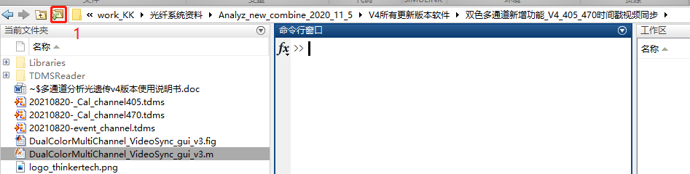
2、Command Window >>Input TrippleColorMultiChannel_VideoSync_gui_v3, then press the Enter button，or right click TrippleColorMultiChannel_VideoSync_gui_v3.m and click button Run.
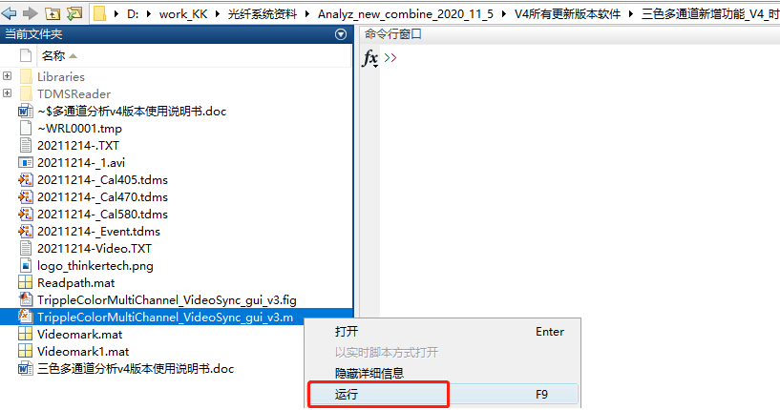
3、After step 2，the analysis window is displayed.
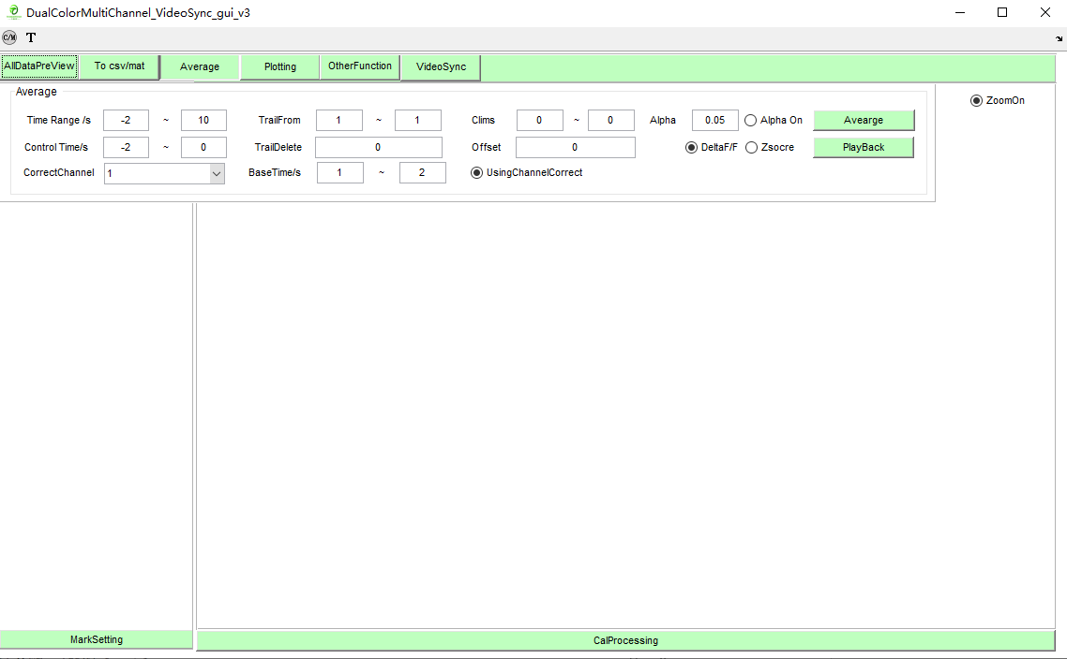
钙信号曲线预览框
4. Read the recorded file：
Click the upper left button to read the raw data.
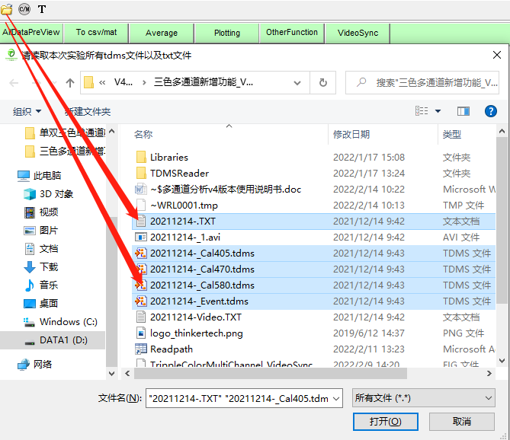
tips: After reading the above data, the program pops up a success message: the program has successfully read the selected file。
5. Pre-processing of calcium signal data：CalProcessing
Press CalProcessing button and set up as follow:
a、CalChannel: Select the calcium channel number that you want to analyze.
b、CalMode：Set the current calcium signal mode，the 470 signal or the 405 signal.
c、SmoothCal：Drag the slider to smooth the calcium signal as shown below。

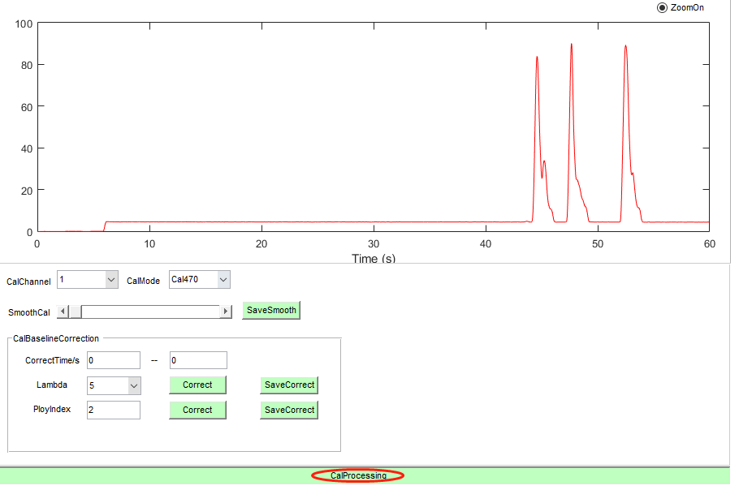
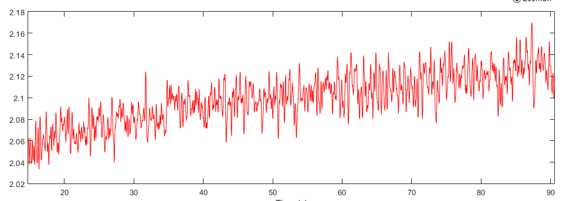
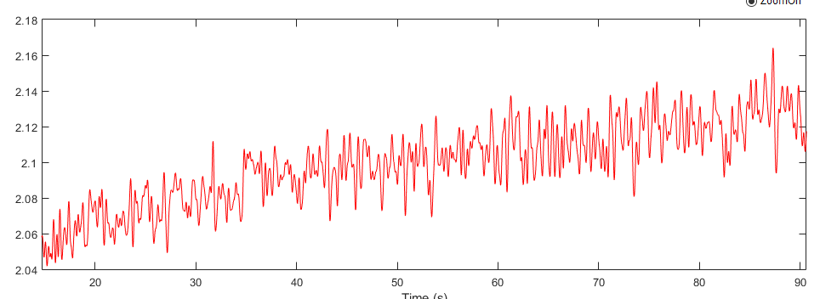
d、SaveSmooth：after setting the smooth factor，save the smooth result. Smooth can be set repeatedly, after a single smooth, save it and drag the slider again to smooth the data.
e、CalBaselineCorrection：Baseline correction of calcium signals。
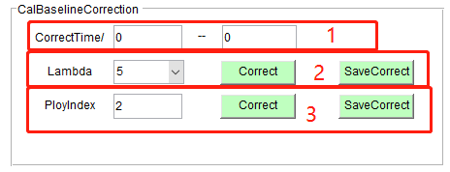
a、Correct time/s：Correction time range (Tips: from the time the animal was plugged in the fiber to the time when the fiber was removed).
b、Lambda：set the Lambda factor as 7-9 and click Correct button.
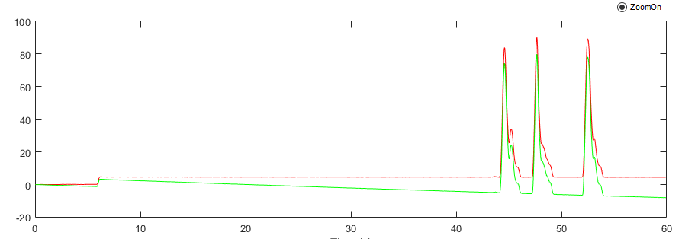
c、PloyIndex：when using the Polynomial correction，we suggest to set the factor as 2. Using polynomial correction baseline, and lambda correction do not conflict with each other.
d、Press the button SaveCorrect , and the corrected data file is generated under the original file path .

6. Marker data Settings：MarkSettingProcessing
Press button MarkSetting to open the marker setting function.
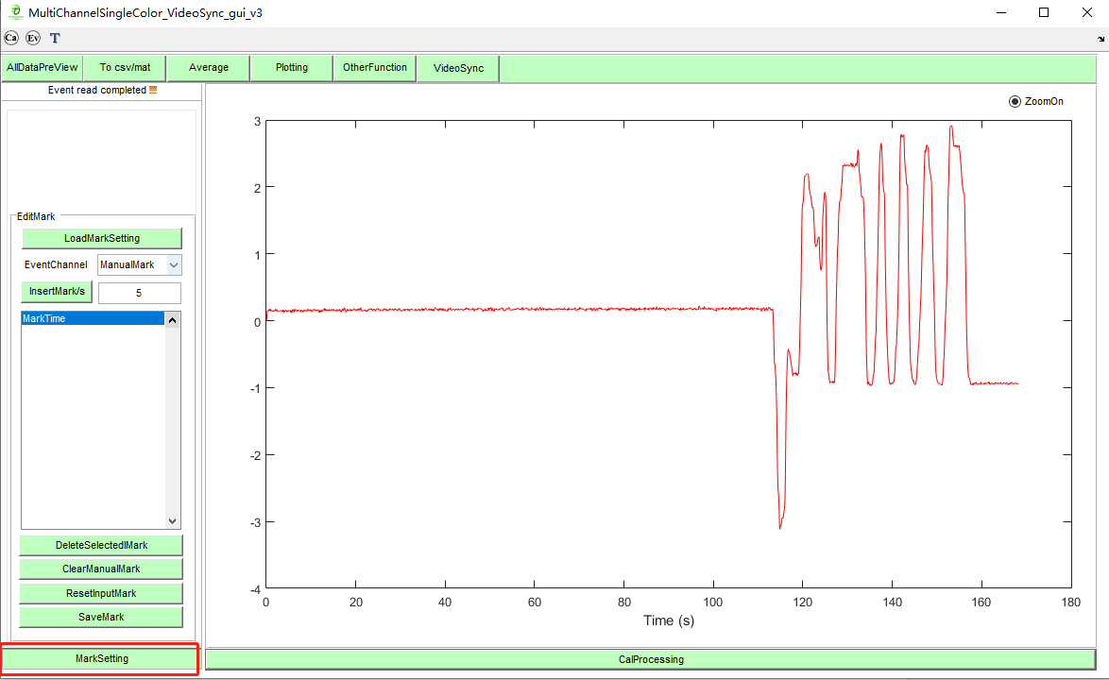
a、press，and select the proper marker channel.
When you switch a marking channel, a MarkTime list displays all marks currently contained in the channel.
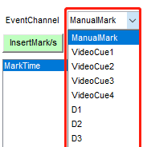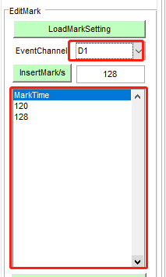
b、press to delete the selected marks.
c、 to clear all the marker.
d、 to reset the markers.
e、to save.

7. ZoomOn
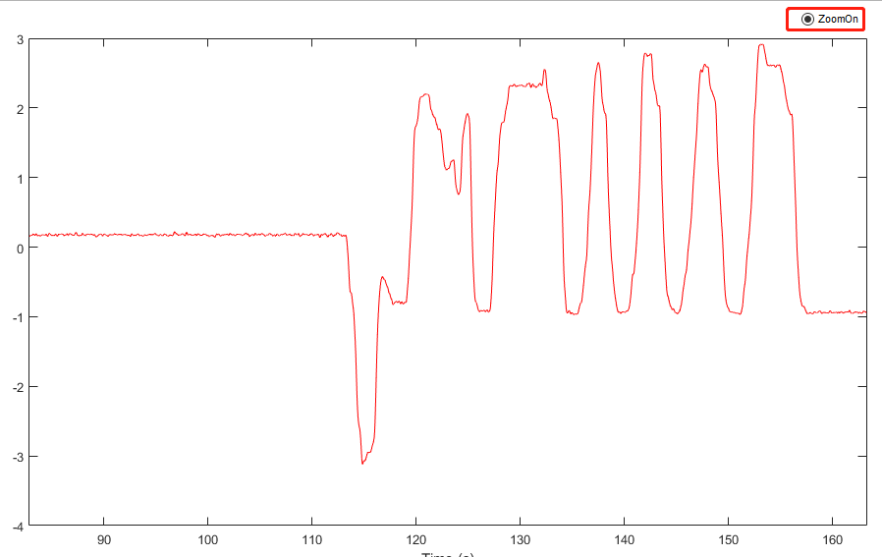
a、Check ZoomOn button to zoom in or out of the current calcium signal channel.
b、if ZoomOn button was not checked, it is allowed to edit markers.

8. Average button module ：Average analysis of multiple trials（Average）
Click button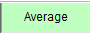 to open average setting module：
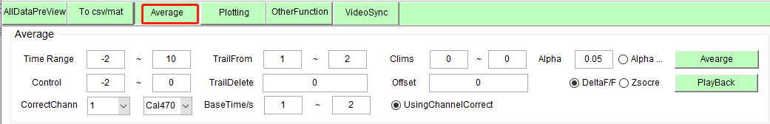
Response trials were marked by the time markers and then calculated as Deltaf/F or Z-score.
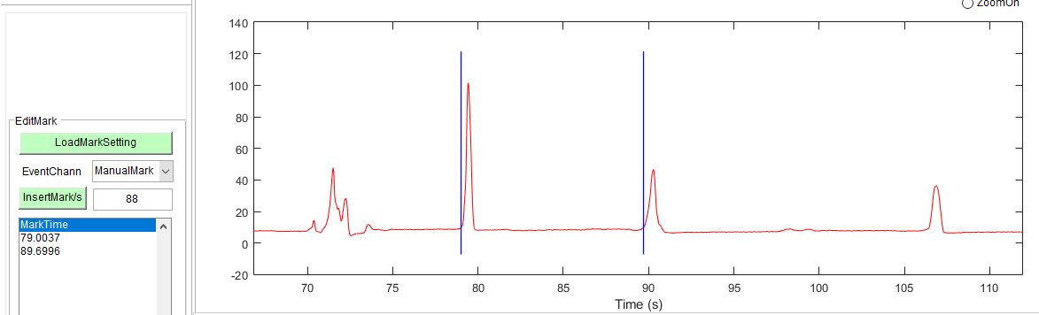
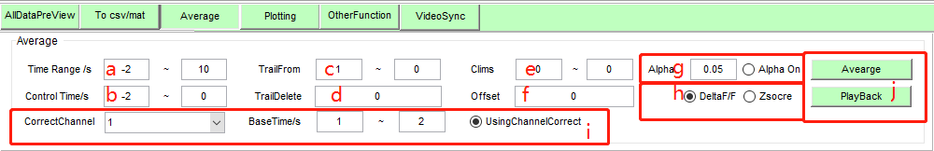
a、TimeRange：From desired baseline period prior to Time 0 (time markers) to the desired response period after Time 0.
b、Control Time：desired baseline period prior to time marker.
c、Trial From：Select the range of trials you want to analyze。
d、TrailDelete：To delete a specific trail in trail from, you can delete multiple trails. Separate multiple trail deletion parameters with Spaces. for example trail from setting 1-5，TrailDelete setting 2 3，the second and third trial analyses pop up in the analysis；
e、Clims：Set the upper and lower limits of the color range for the heatmap drawing. When the value is set to 0, the program will automatically calculate the result of the most appropriate value.
f、Set the Offset value of the corresponding channel (the median value).
Offset：After all parameters of the device are adjusted, the end of the optical fiber is placed in a dark environment. At this time, the value of the channel corresponding to the acquisition software is the Offset signal of the system, which is called the offset value of the calcium signal of the corresponding channel.
g、Significance judgment calculation, the module is set based on references, theoretical method reference.
h、Set the algorithm for analyzing statistics（Deltaf/F of Z-score）.
i、UsingChannelCorrect：Select the combination of reference channels for correction, and input the correction reference time window in the Basetime box (select a baseline time range after the relatively stable mice).
CorrectChannel：Select which channel of another calcium signal is used for correction。
j、Average：Output analysis result。
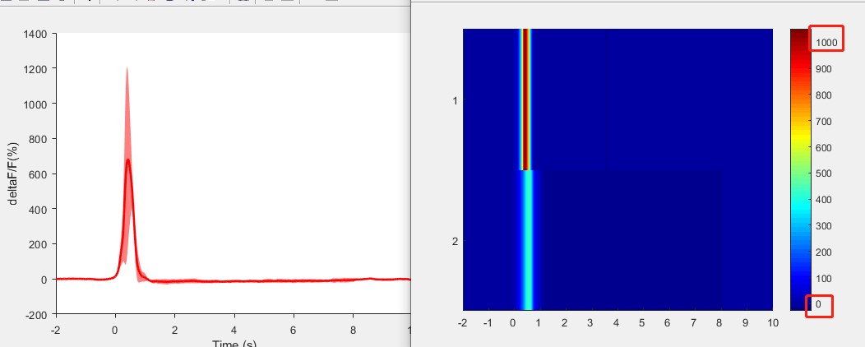
The graph on the left shows the average results of all trials with the shaded part indicating SEM. The Heatmap on the right shows the results of each repeated trail. Save the result.
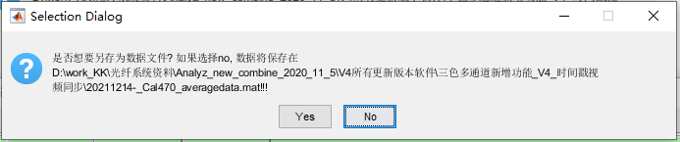Click saved data file to review previous analysis.
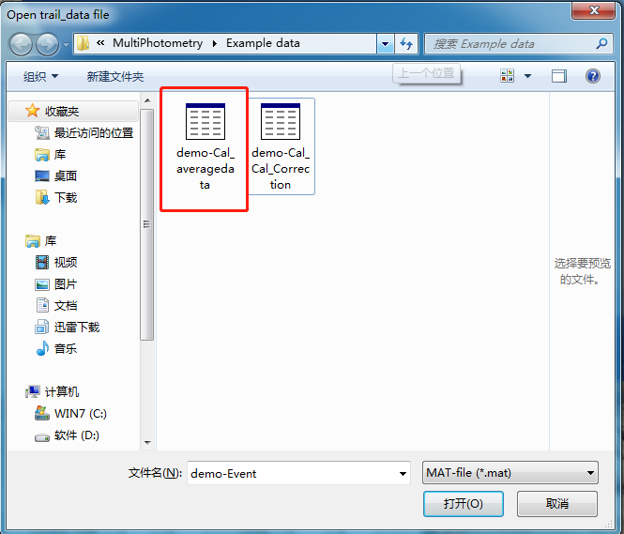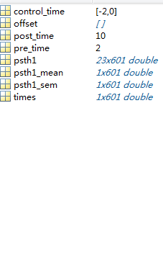

9. OtherFunction button module:
Click button to open OtherFunction module：
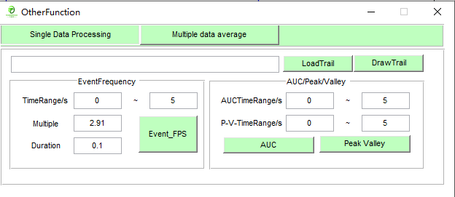

SingleDataProcessing ：
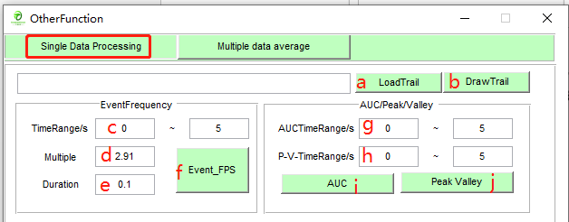
a、Read the mean analysis results of multiple trials (averaged data file).
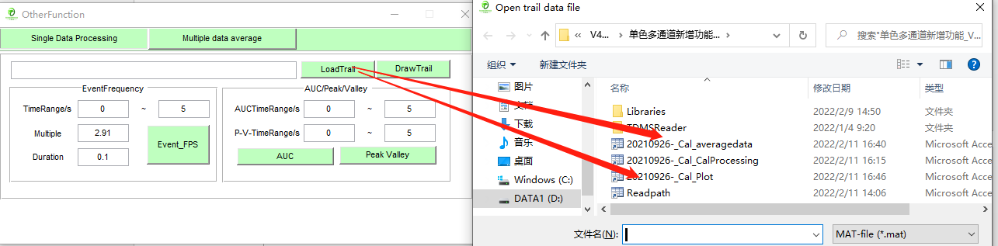
b、View the analysis result of the file.

AUC/Peak calculation：
Calculate the area under the curve of the mean analysis results of multiple trials (averaged data file).
g、Set the time window for calculating the area under the curve. Unit: second.
h、Set the time window for calculating the peak value. Unit: second.
i、Click the AUC button for Area under the curve calculation.
j、Click Peak Valley to calculate the maximum and minimum values.

Multiple data average statement of calculation：
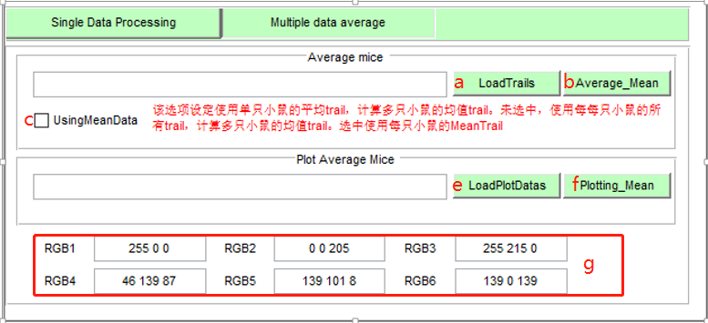

To average data from multiple mice：
a、Click the Load Trials button and select data from multiple mice 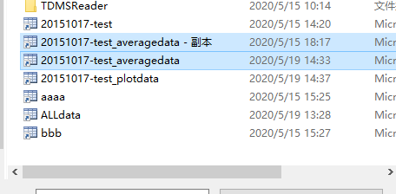
c、If the usingMeanData box is selected, the average of each mouse is used to calculate the mean of multiple mice; If not selected, trials from all mouse were used to calculate the mean trail for multiple mice.
b、Click average button

